Organisational Title
Change Communication Strategy

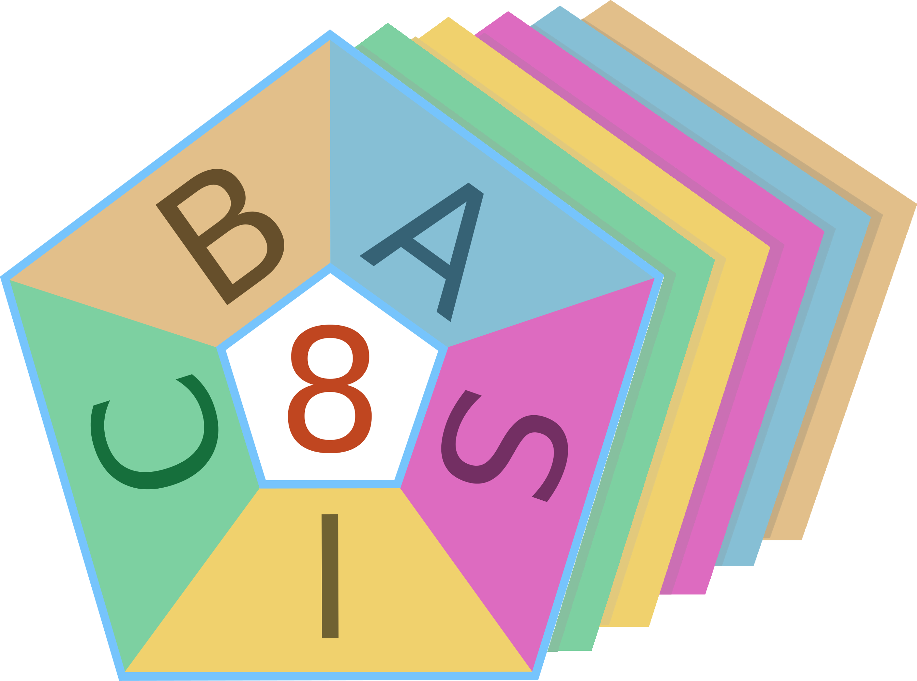
BASIC 8
Simplifying the Complexity of Change
© Five Clyde Pty. Ltd.

Document Controls
Document Owner
Contact Details
Business Unit
Document Status

Revision history
Date | Version No. | Author | Description of changes

Approvals
Name | Title | Signature | Date

Contents

1. Introduction 1
2. Guiding Principles 1
3. Communication Objectives 1
4. Key Participants 2
5. Communication Environment 3
6. Communication Network 6
7. Communication Responsibilities 6
8. Communication Focus Areas 7
9. Compliance with Corporate Standards 8
10. Reporting 8
Appendix A – Initial Communication Events 10

Introduction
(Provide a brief description of the purpose of the plan: the change program it is supporting, the outcomes it will achieve, and how it will facilitate people’s participation in the change. Also note that this plan does not provide the content of communication throughout the change. That will come from the actual activities and issues that arise. The plan provides the strategy, structure, responsibilities and processes for communication that will be used during the change.)

Guiding Principles
(These are the guiding principles for communication during the change. They address the style and criteria for what effective communication will be like. Avoid generic principles. Focus on principles that are relevant to your organisational culture and the characteristics of the people you are dealing with. Principles might include transparency, openness, timeliness, listening, interactive, accountability, coordination, trust, clarity, and reliability. These principles can guide all communication from the formal to informal and for communication with leaders, peers and other stakeholders.)

Communication Objectives
(You may use the text provided for this section and modify the listed objectives to suit any additional elements your organisation requires.)
Certain conditions have to be met if communication during change is to achieve its objectives.
Communication during change can only achieve its objectives if it promotes certainty so people can make effective decisions about the change and how they participate.
Effective communication during change is interactive, multi-directional and responsive. It ensures voices are heard so certainty and constructive participation occurs.
Most communication during change happens spontaneously and informally, driven by the people involved. Formal communication processes support and guide the overall communication content. The role of the plan is to facilitate and guide this dynamic to ensure communication is informed, reliable and constructive.
To meet these three conditions (promote certainty, make voices heard, and facilitate and guide) the objectives of this communication plan are:
- Identify key points and processes in the program that require sharing of information.

- Generate opportunities for groups and individuals to communicate about the program, its implementation and opportunities for improvement.

- Monitor and promote reliable information to support people and decisions.

Key Participants
(Summarise who is involved in the change, their numbers, locations and roles. Then add the following or similar text.)

As well as information required for everyone going through the change, different groups will need targeted communication to match their role in the program and the different ways the program will affect them.
The sub-groups can be provided into three categories:
- Agents, namely people who have role or responsibility for designing and implementing the change program.

- Constituents, namely people who will change how they work within the organisation as a result of the program.

- Bystanders, namely, people who deal with the people in the organisation or the work they produce but are not significantly affected by the changes.
Some people and groups will be both agents and constituents as they work on the projects that affect their roles.
Each person or group has two key requirements in communication, namely to be able to give messages to others and to listen to others. Both of these are needed for effective sharing of information and needs.

(Complete the following tables to provide an overview of the different groups in the change and their place in the communication network. For each group there are two roles. One is their role as messenger, where they are responsible for passing on different types of information. The other is their role as listener, where they are responsible for paying attention to the information others need to convey to them and the information they need to manage their journey through the change.)
Agents
Key Participant Group | Role as Messenger Requirements | Role as Listener Requirements

Constituents
Key Participant Group | Role as Messenger Requirements | Role as Listener Requirements

Bystanders
Key Participant Group | Role as Messenger Requirements | Role as Listener Requirements

Communication Environment
The communication environment evolves during the change process. Not only does everyone go through the five BASIC change phases, different groups do this at different times and in different ways. Communicators must be aware of who is going through which phase, how they are experiencing and the issues they are facing at that point in time.
How groups move through the phases depends on the progress of the change process. Executives generally move into change earlier than individual contributors. People in change agent or project roles enter the change sooner than general business units. When there are pilot programs or a staged roll out of a program, how people move through the change phases depends on where they are in the organisation.
This change plan takes into account the different dynamics happening at any point in time. The table below provides and overview of the expected movement through the phases. For each group the four key change communication agendas are listed and their attributes addressed.

Early participants in the change process
Key people and groups | (List the people and groups who will be first to start going through the change process)
Communication Agenda
Initiation | This agenda corresponds with moving through the Begin and early Align phases. The issues here are about getting people involved and making decisions around accepting the need for change and the importance of their involvement.  (List the expected issues these groups will have to communicate about at this stage in the change.)
Understanding | This agenda corresponds with the late Align phase, the Shape phase and entry into the Implement phase. It is about helping people understand what is going on, why and when. The conversation is about helping people to adjust to the changes. Typically, people feel the most uncertainty for people as plans and details are shared but the changes are still to be put in place. The goal in this phase, as always during the change, is to move people from uncertainty to certainty.  (List the expected issues these groups will have to communicate about at this stage in the change.)
Performance | This agenda is most common in the late Shape phase and throughout the Implement phase. It can also flow into the closure phase to wrap up loose ends. It is about getting practical information to people, such as clear schedules and role expectations. It is also about making sure feedback is getting through to change agents so issues can be resolved and improvements made. This agenda is about making sure people can do what they need to do.  (List the expected issues these groups will have to communicate about at this stage in the change.)
Closure | This agenda corresponds with the Consolidation phase. It is about wrapping up the change. It happens once the results of the change have become normal. It does not happen when any project activity stops but flows into the ordinary business of the organisation, keeping in mind that any project is only a tool of the change and not the change itself. The closure agenda not only consolidates the change but also sets the tone for future change, by acknowledging shortfalls and mistakes as well as celebrating achievements and benefits. It is also important for this agenda to extend to the first review and quality improvement process of the new operating environment, which may be three to twelve months after the most change project activity has ceased.  (List the expected issues these groups will have to communicate about at this stage in the change.)

Middle entry participants in the change process
Key people and groups | (List the people and groups who will be get involved in the change after it has been established by the early group but before it is fully rolled out.)
Communication Agenda
Initiation | This agenda corresponds with moving through the Begin and early Align phases. The issues here are about getting people involved and making decisions around accepting the need for change and the importance of their involvement.  (List the expected issues these groups will have to communicate about at this stage in the change.)
Understanding | This agenda corresponds with the late Align phase, the Shape phase and entry into the Implement phase. It is about helping people understand what is going on, why and when. The conversation is about helping people to adjust to the changes. Typically, people feel the most uncertainty for people as plans and details are shared but the changes are still to be put in place. The goal in this phase, as always during the change, is to move people from uncertainty to certainty.  (List the expected issues these groups will have to communicate about at this stage in the change.)
Performance | This agenda is most common in the late Shape phase and throughout the Implement phase. It can also flow into the closure phase to wrap up loose ends. It is about getting practical information to people, such as clear schedules and role expectations. It is also about making sure feedback is getting through to change agents so issues can be resolved and improvements made. This agenda is about making sure people can do what they need to do.  (List the expected issues these groups will have to communicate about at this stage in the change.)
Closure | This agenda corresponds with the Consolidation phase. It is about wrapping up the change. It happens once the results of the change have become normal. It does not happen when any project activity stops but flows into the ordinary business of the organisation, keeping in mind that any project is only a tool of the change and not the change itself. The closure agenda not only consolidates the change but also sets the tone for future change, by acknowledging shortfalls and mistakes as well as celebrating achievements and benefits. It is also important for this agenda to extend to the first review and quality improvement process of the new operating environment, which may be three to twelve months after the most change project activity has ceased.  (List the expected issues these groups will have to communicate about at this stage in the change.)

Final participants to enter into the change process
Key people and groups | (List the people and groups who will be last to get involved in the change process.)
Communication Agenda
Initiation | This agenda corresponds with moving through the Begin and early Align phases. The issues here are about getting people involved and making decisions around accepting the need for change and the importance of their involvement.  (List the expected issues these groups will have to communicate about at this stage in the change.)
Understanding | This agenda corresponds with the late Align phase, the Shape phase and entry into the Implement phase. It is about helping people understand what is going on, why and when. The conversation is about helping people to adjust to the changes. Typically, people feel the most uncertainty for people as plans and details are shared but the changes are still to be put in place. The goal in this phase, as always during the change, is to move people from uncertainty to certainty.  (List the expected issues these groups will have to communicate about at this stage in the change.)
Performance | This agenda is most common in the late Shape phase and throughout the Implement phase. It can also flow into the closure phase to wrap up loose ends. It is about getting practical information to people, such as clear schedules and role expectations. It is also about making sure feedback is getting through to change agents so issues can be resolved and improvements made. This agenda is about making sure people can do what they need to do.  (List the expected issues these groups will have to communicate about at this stage in the change.)
Closure | This agenda corresponds with the Consolidation phase. It is about wrapping up the change. It happens once the results of the change have become normal. It does not happen when any project activity stops but flows into the ordinary business of the organisation, keeping in mind that any project is only a tool of the change and not the change itself. The closure agenda not only consolidates the change but also sets the tone for future change, by acknowledging shortfalls and mistakes as well as celebrating achievements and benefits. It is also important for this agenda to extend to the first review and quality improvement process of the new operating environment, which may be three to twelve months after the most change project activity has ceased.  (List the expected issues these groups will have to communicate about at this stage in the change.)

Communication Network
Communication will flow through a matrix of groups and responsibilities, reflecting the key participant groups listed in section 4 above. The communication network and pathways of the main groups are:

(Insert a flow chart illustrating the key communication pathways between key groups and people.)

This communication will be supported by a central communication portal, which will include schedules, announcements, news and other key information for the change.
(Insert information about the location of the portal, how it can be accessed and who is responsible for maintaining it and keeping it current.)

Communication Responsibilities
(This section will be redrafted to match the actual governance, project and coordination structures in place. The paragraphs below highlight the various responsibilities to address.)

Communication is both planned and responsive during the change program, implementing planned processes and events and responding to emerging needs and changes. This is managed by distributing responsibility. The core communication responsibilities are:
- Project agents are responsible for their communication with each other about decisions, tasks, coordination and schedules.
- (Insert the name of the person or group responsible) is responsible for maintaining the formal communication infrastructure and facilitating communication as required.
- (Insert the name of the people or groups responsible for governance) will ensure that key messages and decisions are processed by the relevant delegate.
The last of these responsibilities is important for maintaining consistency and accuracy.
Scheduling and Coordination
Most communication events will be scheduled according to the needs of the time, such as:
- Sending key messages when major milestones or decisions occur.
- Organising for senior leaders to meet with groups in need of clarity or support.
- Escalating questions and adding responses to the FAQ in the formal communication portal.
The scheduling of communication is considered part of program and project activities, alerting and involving people as key decisions and activities approach and occur.
It is also part of the local leadership responsibility. Local leaders are the key people who can judge whether their people are sufficiently informed and responding to communication.
(Insert the name of the people or groups responsible for governance) have oversight responsibility as to the sufficiency of communication. All change agent roles share responsibility for providing advice to ensure this goes well.
A calendar of communication events will be maintained by (insert the name of the person or group responsible) to facilitate the coordination of communication.
The exceptions to scheduling based on the project plans are:
- Weekly news update. This is the core communication vehicle for ongoing information. Each week (Insert the name of the person or group responsible) will check with (Insert the name of relevant change agents and senior roles) about current events and issues. It will then prepare a news update to be signed off by (Insert the name of the person or group responsible) before updating the formal communication portal and notifying staff.

- Weekly check with (Insert the name of the reference group/s) about emergent issues. This may be in the form of a teleconference, phone calls or emails. This will be coordinated through (Insert the name of the person or group responsible). Project Managers and senior leaders may choose to attend these meetings.

Communication Focus Areas
(Adjust the communication focus areas to suit your organisation. Channels can include briefing notes, reports, briefings, meetings, plans, emails, the formal communication portal, newsletters, team meetings, branch meetings, staff feedback through supervisors, reference groups, orientation sessions, training sessions, surveys or any other communication opportunity.)
Focus Area | Purpose | Responsibilities & Actions | Channel
Senior leaders’ decisions and advocacy | To maintain up to date information to enable:  - Decisions required for the program.  - Advocacy of the program.  - Management of emergent issues.
Program coordination | To enable coordination, scheduling and consistency across projects, transition and communication.
Program Participation | To give and receive information about:  - Program purpose and goals  - Progress and decisions  - Feedback and issues  - Successes and benefits  - Acknowledgement of effort
Performance and Outcomes | To prepare for and implement the changes by providing operational information that people can use to do their jobs.
Currency and Validity | To continuously check with constituents about the effect, progress and issues related to the program and projects.

Compliance with Corporate Standards
(Note any corporate requirements for communication standards and protocols. This is especially important for information that involves external stakeholders, such as unions, contractors, or contractual partners. It is also highly relevant for information for general publication to customers or the media.)

Reporting
(Describe the governance reporting requirements that match the structure of the program in your organisation. If suitable, add a diagram showing the key lines of reporting. Note that there will be regular reports and triggers for emergent reporting. After the description of the reporting requirements are written, the table can be completed to summarise the purpose and frequency of different reports.)

The following table details the purpose of the different reporting functions.
Report | Purpose | Frequency | Recipients

Appendix A – Initial Communication Events
During the change program a calendar of communication events will be maintained by (insert the name of the person or group responsible). The initial communication events that can be scheduled at this point in the program are listed in the table below.
Week Beginning | Communication Events

